**STI Suite User Manual**

(Version 2.0. Updated on Mar. 15, 2014)

Wei Li and Chunlei Liu

Brain Imaging & Analysis Center, Duke University, Durham, NC, USA

**Introduction**

Quantitative susceptibility mapping (QSM) and susceptibility tensor imaging (STI) are two recently developed imaging methods for quantifying tissue’s magnetic property. Magnetic susceptibility offers a new contrast for high-resolution anatomical imaging; it further provides important information on tissue’s chemical composition, especially myelin and iron, and white matter microstructures of the brain. However, processing QSM and STI still requires advanced technical expertise. The growing application and wider acceptance of this new technique has generated a need for a comprehensive software package that can easily perform all these analysis. Here, we have developed such a tool named “STI Suite”. This software is based on our previous works1-13. In this Matlab-based software package, we have implemented the essential algorithms for phase processing, QSM, STI, and related analysis tools. To facilitate the dissemination and evaluation of these methods, we make STI Suite freely available at http://people.duke.edu/~cl160/ for non-commercial academic use.

STI Suite contains both Matlab command-line functions and graphical user interfaces (GUIs) for phase processing, QSM, STI, and related visualization and ROI analysis tools. In this manual, we will not only include the introduction of the programs, but will also include the physical and mathematical basis for deriving these methods. Please feel free to let us know if you have any questions. We will appreciate the users’ comments and suggestions on STI Suite.

**Contents:**

1. **Release notes** (Page 2)
2. **Command line functions**
3. Laplacian-based phase unwrapping (function: LaplacianPhaseUnwrap). (Page 3)
4. iHARPERELLA method for integrated phase unwrapping and   
   background phase removal (function: iHARPERELLA). (Page 5)
5. QSM using LSQR method (function: QSM_iLSQR). (Page 6)
6. Scaling factors for frequency and susceptibility (function: ScalingFactor). (Page 6)
7. STI using the k-spaced-based method: (function: STI_Parfor). (Page 7)
8. **Graphical User Interfaces (GUIs)** (Page 8)
9. STISuite (main GUI) (Page 8)
10. QSM_GUI (for phase processing and QSM) (Page 9)
11. Gray_GUI (for visualization of gray scale images) (Page 12)
12. Color_GUI (for visualization of RGB images) (Page 14)
13. Gray_ROI (for ROI editing) (Page 15)
14. Customizing GUIs (Page 17)
15. **Test datasets** (Page 18)
16. The magnitude and phase data for QSM (Page 18)
17. The dataset for STI (Page 18)
18. STI dataset (Page 18)
19. **Acknowledgments** (Page 19)
20. **References** (Page 20)
21. **Release notes:**

**Version 2.0**

1. Brian extraction is improved to enable more automatic operation.
2. HARPERELLA function is improved with the size of brain mask unchanged.
3. Variable inputs are enabled.
4. A quick estimation of susceptibility is added.
5. A weighting term is enabled in QSM_LSQR
6. A discussion of QSM pulse sequences was included, which was an accepted abstract for the 2nd QSM and phase contrast workshop.

**2. Command-line functions**

1. **Laplacian-based phase unwrapping (function: LaplacianPhaseUnwrap).**

This method uses a Laplacian-based approach to achieve efficient 3D phase unwrapping4,14. In this method, the unwrapped phase can be derived as follows:

 (1)

Here includes both background phase and local tissue phase.

**Usage:**

>>Unwrapped_Phase=LaplacianPhaseUnwrap(rawphase,'voxelsize',voxelsize,'padsize',padsize);

**Required Inputs:**

Rawphase: Raw unwrapped phase.

**Optional Inputs:**

voxelsize: spatial resolution, e.g. voxelsize =[0.9 0.9 1]; unit mm.

padsize: size of zero-padding to increase numerical accuracy,

e.g. padsize= [10 10 20]; unit voxel

1. **V-SHARP method for background phase removal (function: V_SHARP).**

V-SHARP is modified version of the SHARP method by Schweser et al15. It uses a varying spherical kernel to remove the background phase and preserve the contrast near the boundary of the brain4,11. Briefly, the background phase satisfied Laplacian equation (), therefore, the spherical mean value (SMV) property of Laplacian equation holds, i.e. the mean value of the harmonic phase on a spherical (shell) equals the harmonic phase at the sphere center. The background phase removal process includes two steps. The first step is the SMV filtering:

 (2)

where S represent a SMV convolution kernel. The second step is to remove the invalid points at the region boundary. The final step is to perform a deconvolution to restore the low frequency tissue phase:

 (3)

In this processes, the harmonic phase will no longer be recovered. By defining , Eq. [19] can be rewritten as follows:

 (4)

Eq. 4 can be interpreted as the summation of the SMV filtered phase () and its convolution with the deconvolution kernel *K* ().

Fig. 1a (on next page) shows the changes of amplitude of devolution kernel *K* with varying SMV radius. It can be seen that the power of this devolution kernel is pretty large for small SMV radius, but it drops off rapidly with increasing SMV radius. As a result, using a sphere filter with a small diameter may cause large amplification of the residual phase error as illustrated in Fig.1c where a radius of 3mm was used. On the other hand, using a larger diameter of 8mm led to a much lower level of phase error as seen in Fig.1d. However, the apparent drawback of using a large sphere diameter is the fact that there would be larger number of invalid points at region of support (ROS) boundary that need to be discarded. We use a method with decreasing SMV radius towards the brain boundary to achieve a better compromise between the two (Fig.1e).



*K*

**Fig. 1. Using different sphere diameters in SMV background phase removal****11**: (a) the cross-section of the deconvolution kernels of different diameters r; (b) original unwrapped phase map; (c) background phase removal using a sphere filter of diameter of 3; (d) background phase removal with a sphere filter of diameter of 8; (e) background phase removal with a varying sphere filter diameter from 8 to 3. Using small sphere diameter causes large error amplification (pointed by arrow), using a large diameter cause larger regions at the boundary to be discarded.

**Usage:**

>>[TissuePhase,NewMask,TissuePhaseDecov]=V_SHARP(Unwrapped_Phase,BrainMask,'smvsize',smvsize,'padsize',padsize,'voxelsize',voxelsize);

**Required Inputs:**

Unwrapped_Phase: Unwrapped phase.

BrainMask: A binary brain mask.

**Optional Inputs:**

smvsize: The final largest SMV radius; e.g. smvsize=25;

padsize: size of zero-padding to increase numerical accuracy,

e.g. padsize= [10 10 20];

voxelsize: spatial resolution, e.g. voxelsize =[1 1 1];

Outputs:

“TissuePhase” is the phase before deconvolution.

“NewMask” is the mask after V-SHARP, which is slightly smaller than the original “BrainMask’.

“TissuePhaseDeconv” is the phase after deconvolution.

**Two viable options:**

**Option 1:** using medium to large SMV radii (r) for filtering, e.g. from 8 mm towards 1 mm at region boundary, and then apply de-convolution with the largest radius. In this way, both low phase error and the integrity of the phase map are achieved. The drawback is the inexact devonvlolution of the boundary regions, which is tolerable as the brain region of interest is within the cortex, whose susceptibility is relatively uniform.

**Option 2:** according to Fig. 1a, if the r is sufficiently large, the amplitude of deconvolution kernel is negligible. As such, we can filter the brain with large SMV filter size, e.g. from 25 mm towards 1 mm at the brain boundary. Then we can neglect the step of devolution.

1. **HARPERELLA for phase unwrapping and background phase removal (function: HARPERELLA).**

HARPERELLA (harmonic background phase removal using Laplacian) allows 3D phase unwrapping and background phase removal in a single step1. The Laplacian of the phase can be derived from the sine and cosine functions of the wrapped phase4:

 (5)



Fig. 2. A diagram of the different regions in the FOV: *I* and *O* are interior and boundary regions of the brain, respectively, and *E* is the exterior of the brain that are within a distance of the spherical kernel radius.





In this method, we applied the spherical mean value filtering to estimate the phase Laplacian outside the FOV. Let *I* and *O* be the interior and boundary regions of the tissue respectively, and *E* is the relative complement of *I* and *O* with respect to the FOV, i.e. I ∪ O ∪ E = FOV (Fig. 2). Region *O* is the set of tissue voxels next to the boundaries that are within a distance of the radius of the spherical mean value filter. Then the phase Laplacian within the region of *E*, , shall be the solution of the following minimization problem:

 (6)

where “S” represents the spherical mean value operator over a sphere centered around a given spatial location, and the residual susceptibility sources *δ* are estimated as the mean over trustable region *I*

 (7)

The reason why  has to satisfy Eq. 6 is that phase contributions from sources outside the FOV have been already removed by the Laplacian operator. When sources within E are also removed, the only remaining susceptibility sources originate from the region of I ∪ O. Because of the inaccuracy at the boundary region O, these remaining sources are estimated based on region I as given by Eq. 7. In short, Eq. 6 simply states that when all background sources are removed, the only sources of phase reside in the trustable region.

Once is determined, the Laplacian for the whole FOV, , can be determined as

 (8)

Finally, the background removed and unwrapped phase can be obtained using the following FFT-based inverse Laplacian:

 (9)

It is emphasized that HARPERELLA achieves both phase unwrapping and background phase removal in a single integrated procedure purely based on the Laplacian operator.

**Usage:**

>> [TissuePhase,NewMask]=HARPERELLA(rawphase,BrainMask,'voxelsize',voxelsize,'padsize',padsize,'niter',niter,'radius',radius);

**Required Inputs:**

rawphase: Raw unwrapped phase.

BrainMask: A binary brain mask.

**Optional Inputs:**

voxelsize: spatial resolution, e.g. [1 1 1];

padsize: size of zero-padding to increase numerical accuracy,

e.g. [10 10 20];

niter: Number of interactions for solving Eq. [6]. Default niter=40. Larger nIter will give better results but need long time.

radius: SMV Kernel size; e.g. 8;

1. **QSM using LSQR method (function: QSM_LSQR).**

This function calculates the apparent magnetic susceptibility from the background-removed phase by solving the following equation using LSQR method4.

C:\Users\Bing\Desktop\2.tif  (10)

It his noted that this method did not use constraints or regularizations. As shown in Fig. 3, the structures revealed by magnitude, phase, and susceptibility is different.



Fig. 3. Representative gradient echo magnitude, phase and magnetic susceptibility of cerebellar nuclei, showing different anatomical profiles.

Fig. 4. High resolution of QSM images with matrix size of 1024x512x512.

In this regard, the LSQR method can be advantageous by avoiding unnecessary boundaries from other image contrasts. In addition, LSQR method provides easy handling of large datasets for QSM (Fig. 4)

**Usage:**

>> Susceptibility = QSM_LSQR(TissuePhase,NewMask,'H',H,'voxelsize',...

voxelsize,'padsize',padsize,'niter',niter,'TE',TE,'B0',B0);

**Required inputs:**

TissuePhase: Background removed phase.

NewMask: Updated mask after background phase removal, slightly smaller than the original brain mask.

**Optional inputs:**

H: Vector representation the field direction, e.g. H=[0 0 1];

voxelsize: spatial resolution, e.g. voxelsize =[1 1 1]; unit mm.

padsize: size of zero-padding to increase numerical accuracy,

e.g. padsize= [10 10 20]; unit voxels.

niter: Number of interactions for solving Eq. [10]. Default niter =30. Larger niter will give better results but need long time.

Phaseweights: A weighting matrix with the same size as TissuePhase

1. **Scaling factor for frequency and susceptibility (function: ScalingFactor).**

**Usage:**

>> SF=ScalingFactor(B0,TE_ms);

**Inputs:**

B0: B0, e.g. B0=3;

TE_ms: TE in the unit of ms, e.g TE=30.

In this function, the scaling factor is calculated as:

SF.X = 1/(gamma*B0*TE);

SF.Freq=1/TE/2/pi;

Then frequency shift and susceptibility can be obtained by:

>> FrequencyShift=TissuePhase*SF.Freq;

1. **STI using a k-spaced-based method: (function: STI_Parfor)**

This function calculates the susceptibility tensor in the k-space using multi-orientation background-removed phase. It allows parallel computing using multi-core CPU2,5,8,12.

This method solves the susceptibility tensors using the following equation5:

 (11)

For easier computation, we solved them in another equivalent form8,12. Briefly, in *k*-space, the normalized frequency shift, , can be represented as a weighted summation of susceptibility tensors as8:

 (12)

where

 ()

 ( ) (13)

 is the direction of the applied field, whose elements are *Hi*, **k** is the spatial frequency vector, whose elements are *ki*,, γ is the gyromagnetic ratio of water proton, *H*0 is the magnitude of the applied magnetic field, and *χ* is the second-order (or rank-2) susceptibility tensor. Susceptibility tensor can be estimated by solving the following linear equations in k-space:

 (14)

where A is the coefficient matrix, whose elements are *aij*, and **χ** is a vector of *χij*. The susceptibility tensors were calculated with direct inversion of Eq.14, followed by inverse Fourier transform.

**Usage:**

>> [X_tensor]=STI_Parfor(Phase4D,H_Matrix,B0,TE_ms,parallel_Flag);

**Inputs:**

Phase4D: 4D dataset the 4th dimention is orientation. e.g.

size(Phase4D)=[128,128,128,n]; % n directions

H_Matrix: the H matrix

e.g. H= [0.0072 -0.8902 -0.4556 % direction 1

0.1121 -0.2320 -0.9662 % direction 2

........

-0.1384 0.7923 0.5942]; % direction n

parallel_Flag: parallel computing flag. Recommend 'off' for initial trial.

**3. The graphical user interfaces.**

These GUIs provide the graphical interfaces for QSM, visualization of grayscale images, visualization of RGB images, and the ROI-editing tools. The advantages of these GUIs are their direct access to Matlab workspace, and their easy modification using Matlab guide to incorporate new features and functionalities.

1. **STISuite, the main GUI for STI Suite**

This GUI allows access to templates of the above functions, related GUIs and documentation.

**Matlab command:**

>> STISuite

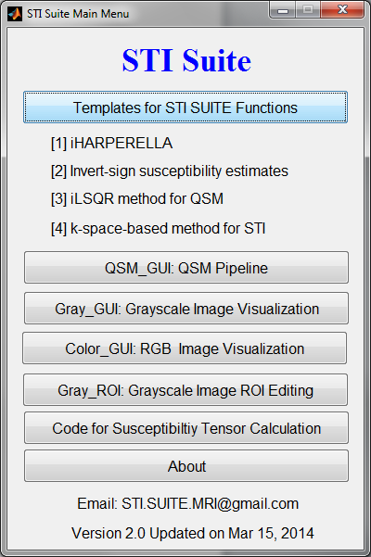

1. **QSM_GUI for phase processing and QSM.**

**Matlab command:**

>> QSM_GUI

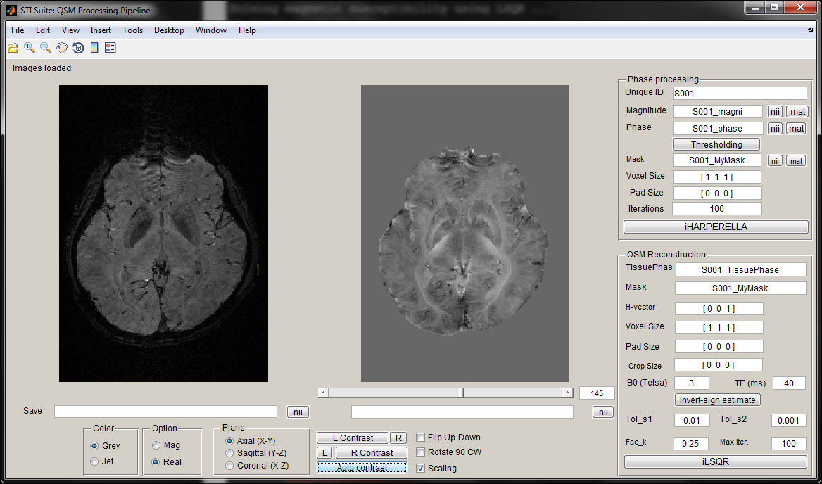

**Step 1: Set an Unique ID**

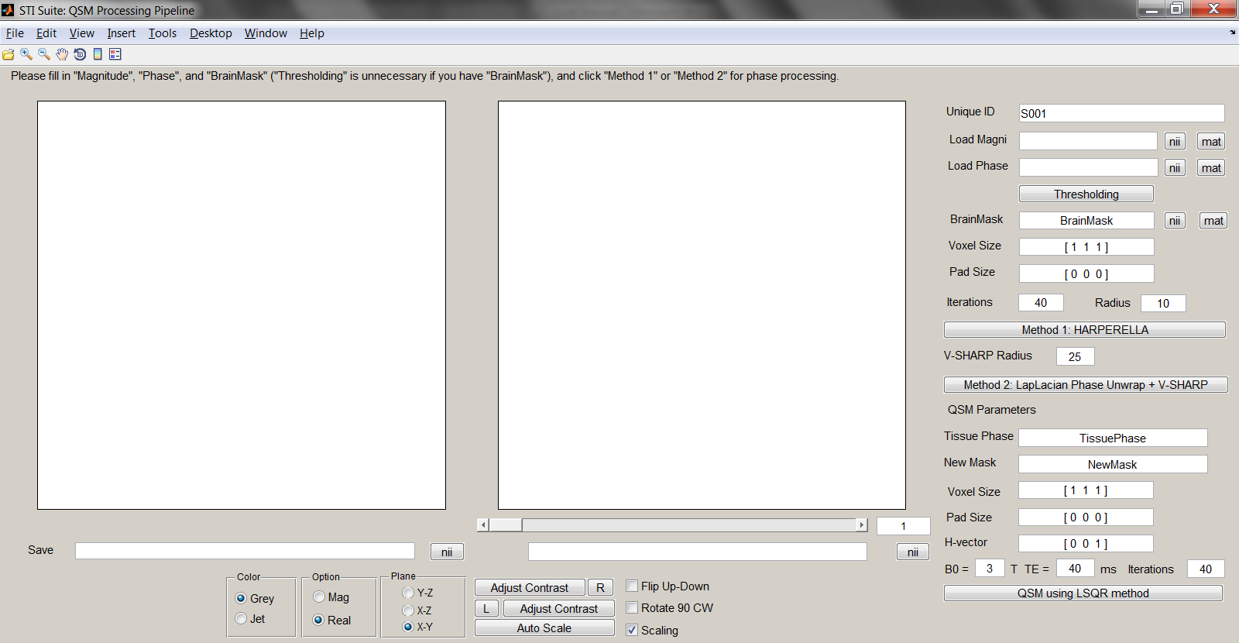

Please select a unique ID, so that our processed data will be saved into Matlab workspace starting with this ID. In this example, we will use “S001”.

**Step 2: Load the data (3 options)**

Option 1: If we have data in Matlab workspace, we can type into the Edit box right to: “Load Magni” and “Load Phase”

**Trick: simple calculation is allowed in the edit box: e.g. Magnitude.*BrainMask**

Option 2: If we have *.nii or *.nii.gz data on disk, we can click the “nii” button to load them. The GUI will name them as “S001_magni” and “S001_phase”, and save them to workspace.

Option 3: If we have *.mat data on disk, we can click the “mat” button to load them in. The GUI will name them as “S001_magni” and “S001_phase”, and save them to workspace.

Trick 1: Once the data is loaded, we can save data to workspace (using edit box), or to *.nii file.



Trick 2: We can adjust the images using the user control groups



This allows us to switch between grayscale and pseudo-color, between magnitude and real, to change the viewing plane, to adjust contrast, and auto-scale contrast, etc. More detailed illustration will be given in “Gray_GUI”.

**Step 3: Generate or load brain mask (4 options)**



Option 1: Press “Thresholding” button to trigger the following window:

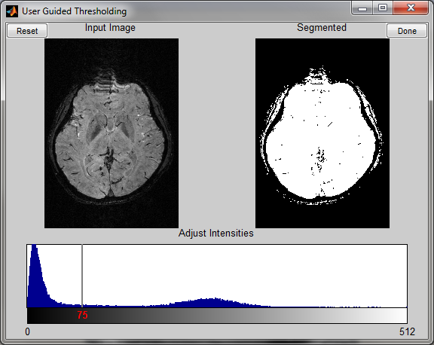

We can adjust the desirable threshold level, and press “done” to start the thresholding. After a few seconds, the thresholding will be done, and a mask binary image will replace the origional phase images in the GUI, and in the meantime, a variable named “S001_MyMask” will be saved into workspace.

Option 2: If we have the mask data in Matlab workspace, we can type the name into the Edit box next to “BrainMask”.

Option 3: If we have *.nii or *.nii.gz data on disk, we can click the “nii” button to load it. This GUI will name it as “S001_Mask”, and save it to workspace.

Option 4: If we have *.mat data on disk, we can click the “mat” button to load it. This GUI will name it as “S001_Mask”, and save it to workspace.

**Step 4: Setting voxel size, zero padding size, and choose the phase processing methods**

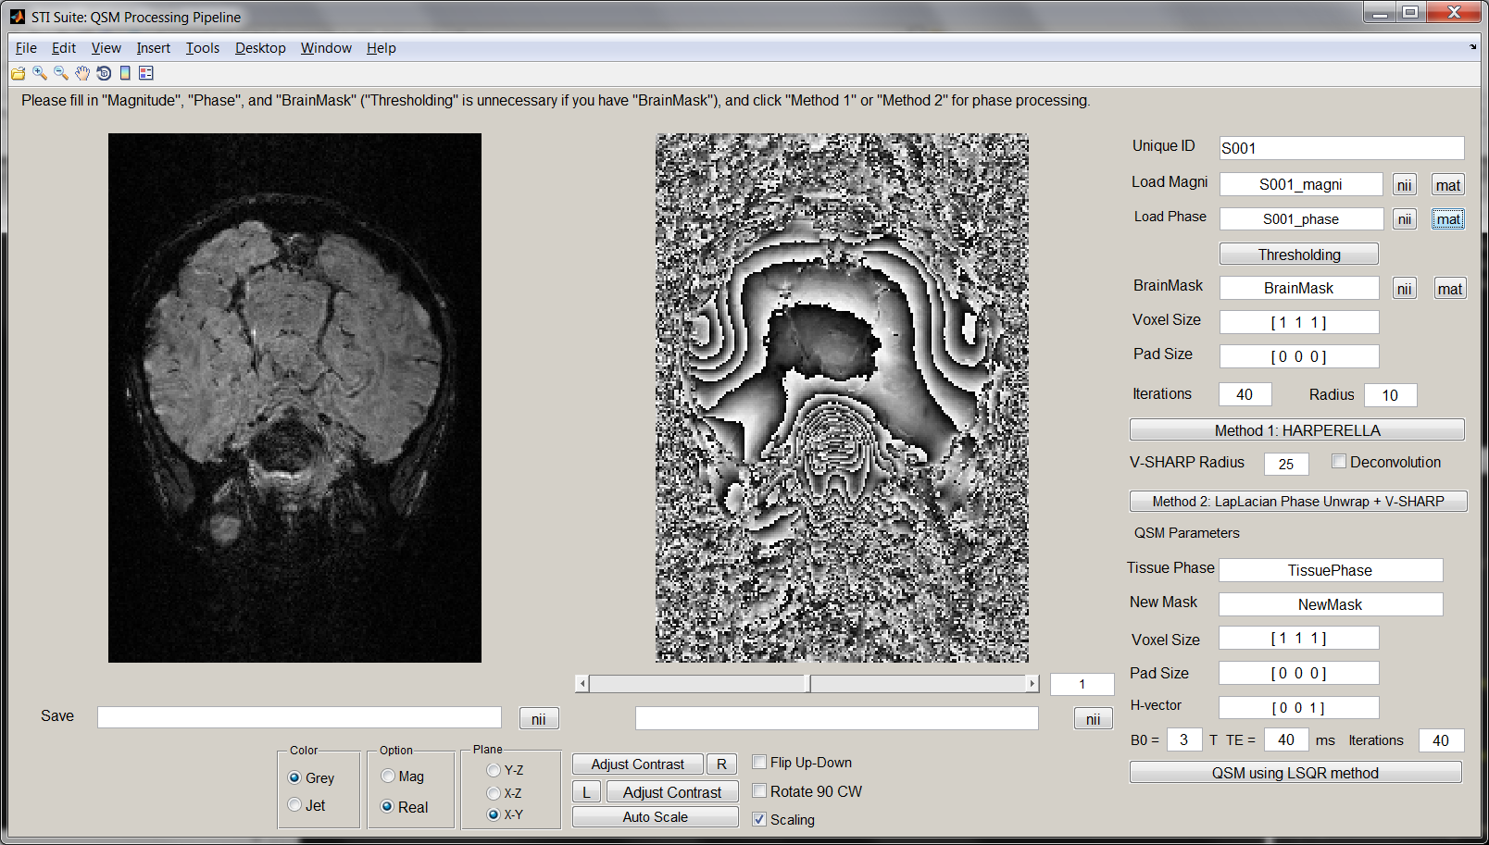

Please set the voxel size, in the format of [x y z], in the unit of mm;

Please set the zero padding “Pad size”, in the format of [x y z], with the unit of voxels. Zero padding will increase the accuracy of Fourier transform. Typically, we recommend to zero-pad it to 256x256x256 mm3.

Next, please select **ONE** of the two methods for phase processing:

***Method 1:*** **HARPERELLA.** Please fill in “Iterations” and SMV Kernel size (“Radius”) for HARPERELLA. Default Iterations = 40. Larger Iterations will give better results but need long time. Default Radius = 10. Radius can be varying from 6~12 mm;

Once the phase processing is done, the filtered phase “S001_TissuePhase_H” and an updated mask “S001_NewMask_H” will be saved to workspace, and filled in the edit boxes for QSM processing in the next step.

***Method 2:*** **Laplacian-phase unwrapping + V-SHARP.** Please fill in maximum SMV Radius. Default value is 25 mm. The V-SHARP will use decreasing SMV radius from 25 mm at the brain center to 1 mm towards brain boundary. There is an option of deconvolution. Default “off”. This is explained in the command function of V-SHARP (Page 3).

Once the phase processing is done, the filtered phase “S001_TissuePhase_V” and an updated mask “S001_NewMask_V” will be saved to workspace, and filled in the edit boxes for QSM processing in the next step.

**Step 5: Setting QSM parameters and run QSM using LSQR method**



Using the tissue phase and the new mask, we can specify the other parameters and run QSM using the LSQR method.

Once QSM is done, a variable named as “S001_Susceptibility” and “S001_FrequencyShift” will be saved to the workspace.

“S001_Susceptibility” is the susceptibility map that we want in the unit of ppm.

“S001_FrequencyShift” is the tissue phase that we may be interested, in the unit of Hz.

**Step 6: Saving results**

Now all results are in Matlab workspace, we can use save the Matlab files. Alternatively, we can save them to *.nii file using Gray_GUI.

1. **Gray_GUI for visualization of gray scale images**

**Matlab command:**

>> Gray_GUI

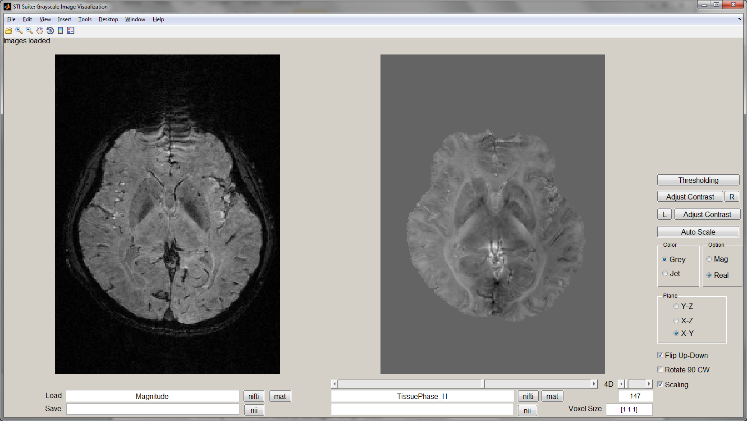

There are two image axes, which allow the visualization of two different images simultaneously.

**Step 1: Load the data (3 options)**

Option 1: If we have data in Matlab workspace, we can type into the Edit box in the same horizontal level as “Load”, the left one allow us to load images into the left image axes, and the right one allow us to load images into the right image axes.

Option 2: If we have *.nii or *.nii.gz data on disk, we can click the “nifti” button to load them. Left “nifti” button corresponds to left image axes, and the right one corresponds to right image axes.

Option 3: If we have *.mat data on disk, we can click the “mat” button to load them. Left “mat” button corresponds to left image axes, and the right one corresponds to right image axes.

**Save the data (2 options)**

Once the data is loaded, we can save data to workspace (using edit box), or to nii files. Again, the buttons and edit box on the left correspond to data in the left image axes, and those on the right correspond to the data in the right image axes.

Important: saving *.nii file needs vixel size, Please fill in them with the unit of mm.

**Zooming the images**



Zooming is enabled. Uncheck “Scaling” to enable zooming for subsequent slices.

**Adjust image contrasts**

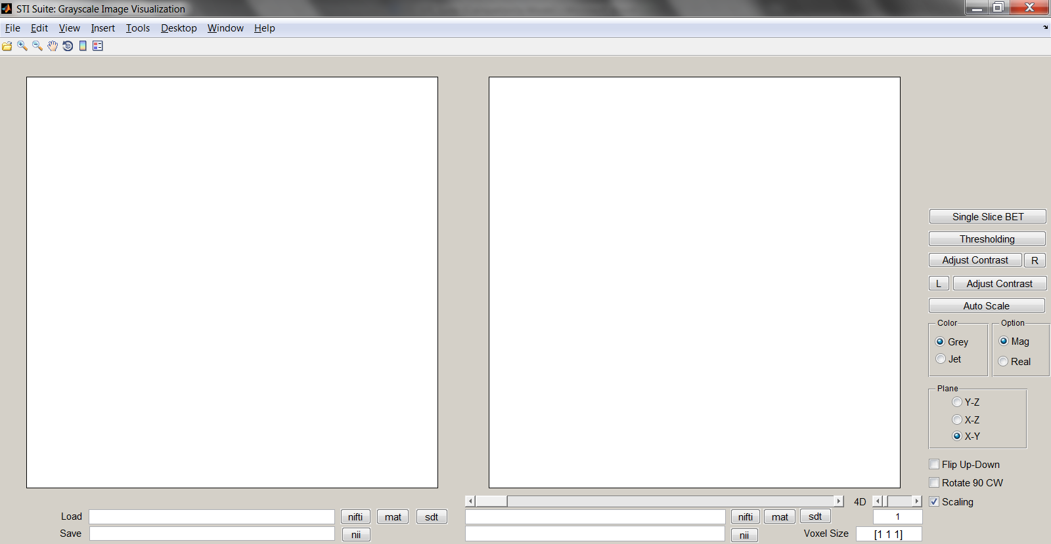

We can click the left “adjust contrast” to trigger the following window:

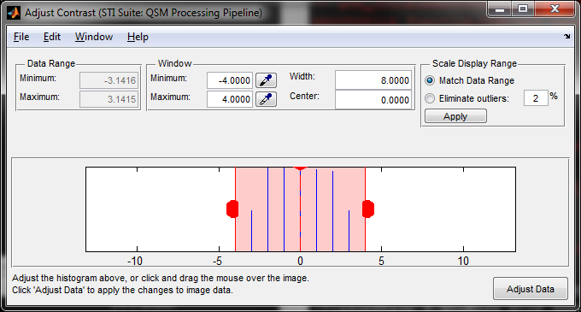

We can use this to adjust the contrast in left image axes. We can click “R” to force the images in the right image axes to have the same contrast as the left one. Similar for the two buttons below them. We can click auto scale to adjust contrast automatically.

**Switch between gray and color scales and between magnitude and real**

This can be archived using the follow radio buttons



**Change the image plane, flip and rotate images**

This can be archived using the follow radio buttons and check boxes.



**Viewing 3D and 4D datasets**

Gray_GUI allow us to visualize both 3D and 4D dataset. We can click the slide bars for the 3rd (left) and the 4th (right) dimensions, to view different image slices or volumes.



1. **Color_GUI for visualization of color-scale images**

Matlab command:

>> Color_GUI

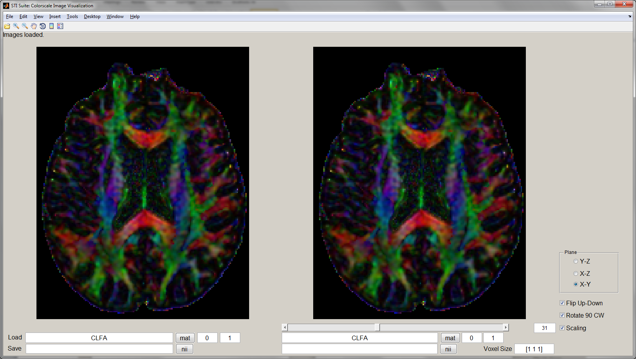

The use of this GUI is very similar to that of Gray_GUI. This GUI allows display of 4D RBG images. The size of the 4th dimension should be 3, which corresponds to red, green and blue, respectively. This one is useful for visualization of colored FA maps, and colored susceptibility anisotropy maps.

1. **Gray_ROI for ROI editing.**

Matlab command:

>> Gray_ROI

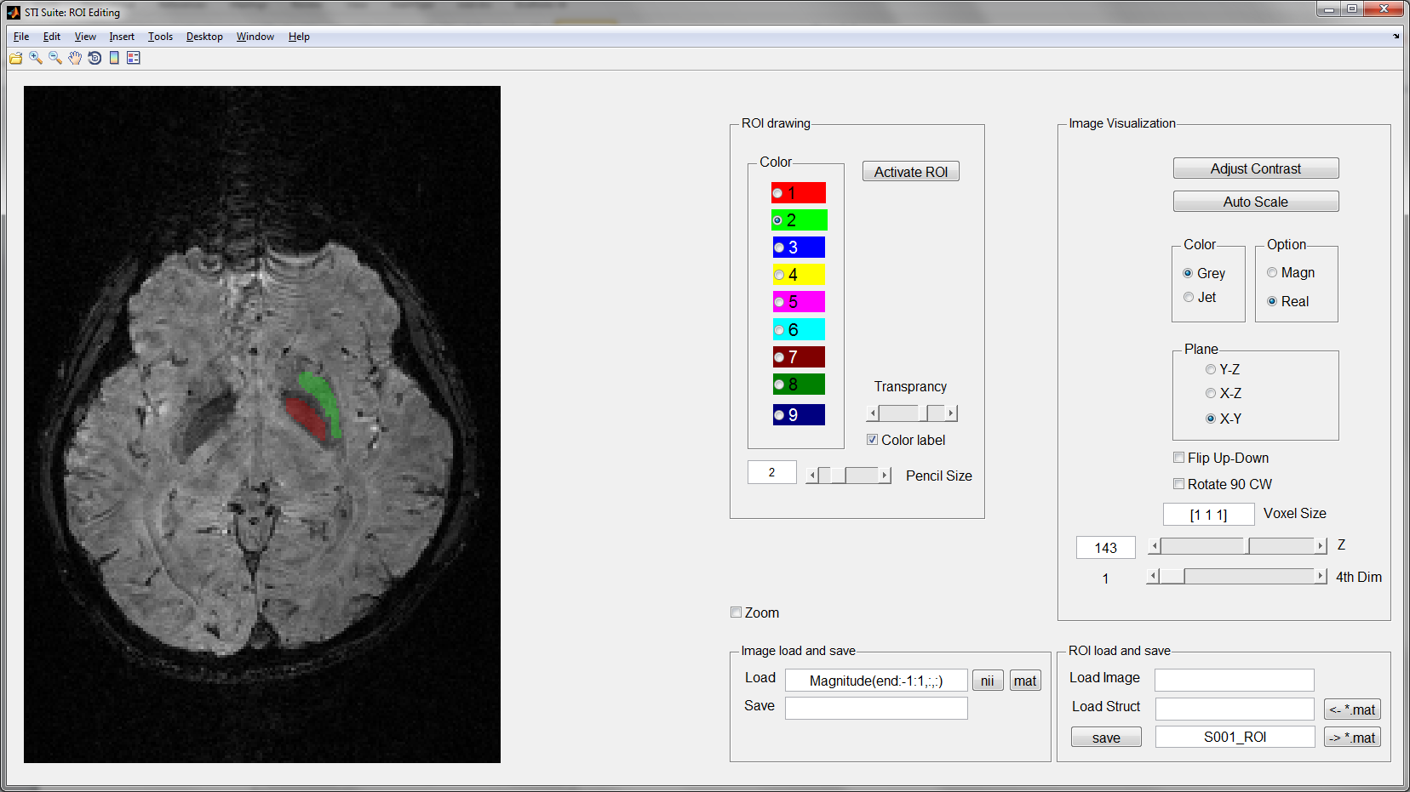

**Step 1: Load the data (3 options)**

Option 1: If we have data in workspace, we can type the name into the Edit box next to “Load”.

Option 2: If we have *.nii or *.nii.gz file, we can click the “nii” button to load them.

Option 3: If we have *.mat file, we can click the “mat” button to load them.

**Important:** The mouse middle wheel is enabled for navigation through different slices.

**Step 2: Activate ROI editing and draw ROIs**

1. Push the “Activate ROI” button
2. Select the color
3. Set ROI color transparency
4. Select pencil size
5. Drawing ROI. During this, we can:

Use mouse wheel to navigate through different slices;

Change color labels to select different ROIs.

**Step 3: Save and load ROIs (2 options)**

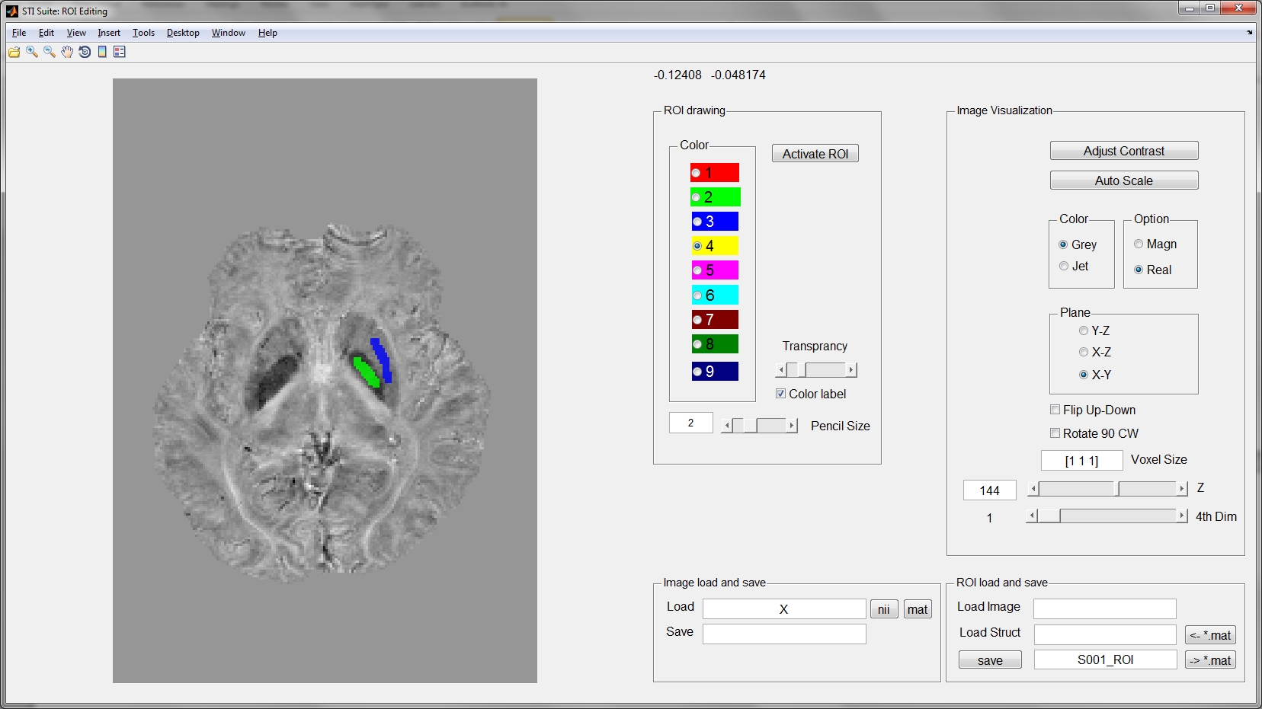

**Option 1:** Fill in the ROI name, e.g. “S001_ROI”. Then click “save” to save it to workspace.

Two files, i.e. “S001_ROI_image” and “S001_ROI_struct” will be saved to workspace.

We can use “Load Image” to load “S001_ROI_image” into Matlab.

We can use “Load Struct” to load “S001_ROI_struct” into Matlab.

**Option 2:** Click “->*.mat” button to save the ROI structure to *.mat file.

Click “<-*.mat” button to load the *.mat file into Matlab.

**Note**: We can load in both 3D and 4D data.

This allows ROIs for each volume of the 4th dimension. Save separate 3D ROIs for each volume.

**Zooming the images**



Zooming is enabled. Uncheck “Zoom” to enable zooming for subsequent slices.

**12) Customizing GUIs**

It is impossible to set a single set of parameters for different monitors with different resolutions and different DPIs. It is noted that the layout of this user interface is optimized for Windows 7, default text size (100%). It may not display ideally using monitor settings. In this case, the users can customize the GUI according to their own preference. For example:

>> guide Gray_ROI

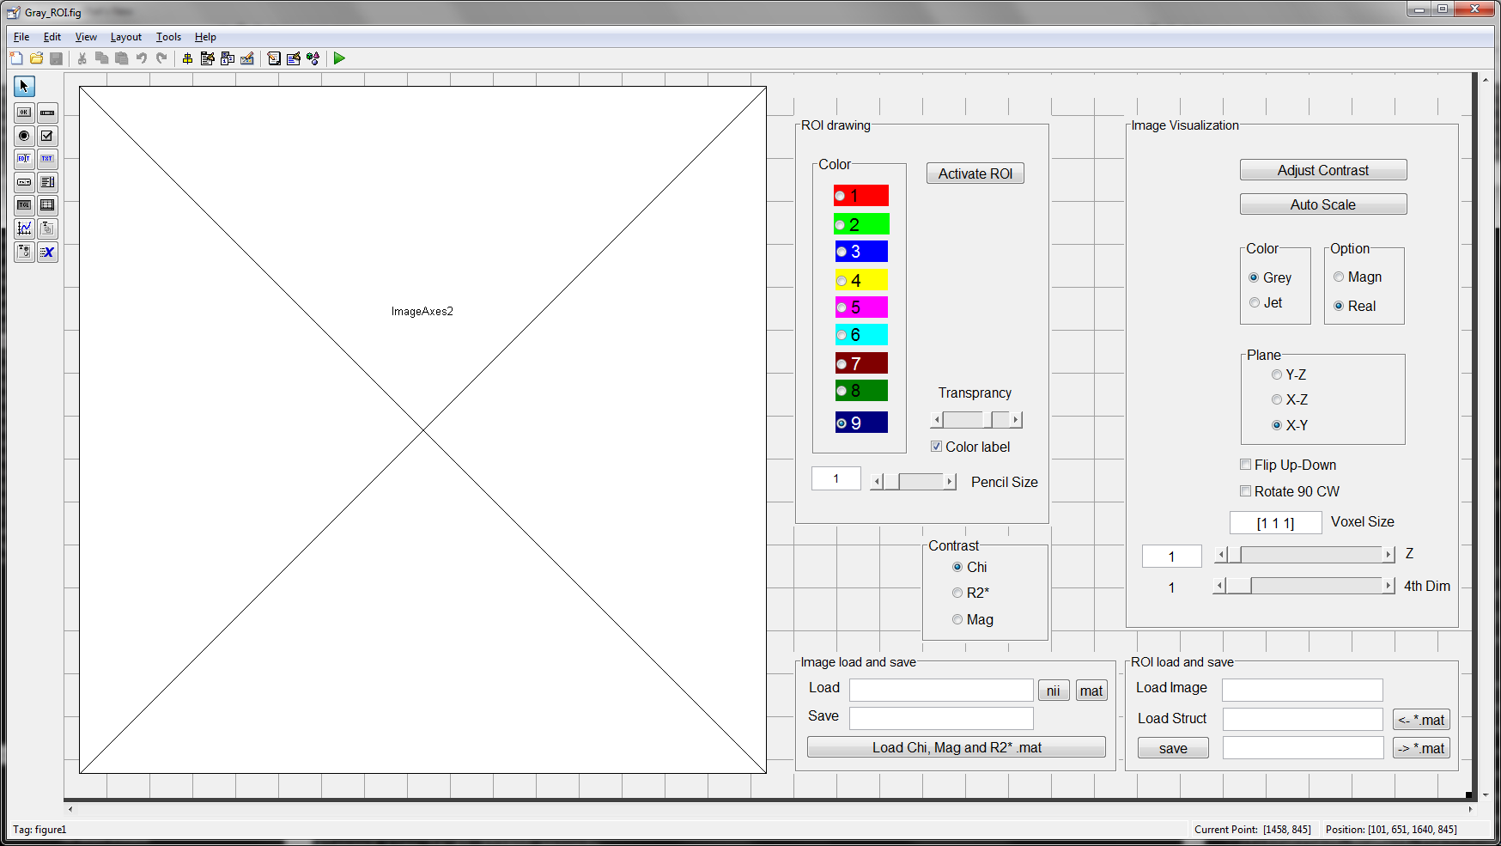

We can use this interface to modify the size and layout of all the elements.

The advantage of Matlab GUI is its easy modification. With basic knowledge of Matlab GUI, we can easily add functions as we want. The following is the basics of our GUIs:

1. You can add elements, name it as e.g. “mypushbutton” in property inspector, and right click the element to view callback function
2. Add the function that you want to use, e.g. “Myfun”

mypushbutton_Callback(hObject, eventdata, handles)

Myfun(hObject,handles)% new added functions

1. Create a function with the name of “Myfun” with basic structure as follows:

function Myfun(hObject,handles)

... % detailed functions

guidata(hObject, handles);

Note: All data is saved in handles.

**3. Test Dataset**

Dataset for testing QSM method

Magnitude.mat

phase.mat

BrainMask.mat

Dataset for testing Color_ROI

CLFA.mat

Data set for STI

Phi_Prohance1.mat

H_Prohance1.mat

UpdatedMask1.mat

**4. Acknowledgments**

* The scripts for *.nii files are based on the work of Jimmy Shen, downloaded from Matlab Central: http://www.mathworks.com/matlabcentral/fileexchange/8797-tools-for-nifti-and-analyze-image
* We acknowledge Dr. Bing Wu, former postdoc from Liu’s laboratory, for his contribution in developing some of the methods.
* We acknowledge Dr. Alexandru Avram, former PhD student from Brain Imaging and Analysis Center, for his contribution in the HARPERELLA method.
* Dr. Chunlei Liu is supported by National Institutes of Health (NIH) through grant [R00EB007182](http://www.sciencedirect.com/science/article/pii/S1053811911000164#gts0005), grant R01 MH096979, and by National Multiple Sclerosis Society through grant RG4723 for performing the research that generated these softwares.
* Dr. Wei Li, former postdoc from Liu’s Laboratory, developed this software under the supervision of Dr. Liu. He is currently a research assistant professor at University of Texas Health Science Center at San Antonio and will continue to provide support to STI Suite.
* For questions regarding this software, please email: [STI.Suite.MRI@gmail.com](mailto:STI.Suite.MRI@gmail.com). We wish to keep a record of the users for improving the software.
* We appreciate the users’ comments and suggestions for improving **STI Suite**.

**5. References**

**1.** Li W, Avram AV, Wu B, Xiao X, Liu C. Integrated Laplacian-based phase unwrapping and background phase removal for quantitative susceptibility mapping. *NMR in Biomedicine.* 2013:n/a-n/a.

**2.** Li W, Wu B, Avram AV, Liu C. Magnetic susceptibility anisotropy of human brain in vivo and its molecular underpinnings. *Neuroimage.* 2012;59(3):2088-2097.

**3.** Li W, Wu B, Batrachenko A, et al. Differential developmental trajectories of magnetic susceptibility in human brain gray and white matter over the lifespan. *Human Brain Mapping.* 2013;doi: 10.1002/hbm.22360.

**4.** Li W, Wu B, Liu C. Quantitative susceptibility mapping of human brain reflects spatial variation in tissue composition. *Neuroimage.* 2011;55:1645-1656.

**5.** Liu C. Susceptibility tensor imaging. *Magn. Reson. Med.* Jun 2010;63(6):1471-1477.

**6.** Liu C, Li W. Imaging neural architecture of the brain based on its multipole magnetic response. *NeuroImage.* 2013;67:193-202.

**7.** Liu C, Li W, Johnson GA, Wu B. High-field (9.4 T) MRI of brain dysmyelination by quantitative mapping of magnetic susceptibility. *Neuroimage.* 2011;56(3):930-938.

**8.** Liu C, Li W, Wu B, Jiang Y, Johnson GA. 3D Fiber tractography with susceptibility tensor imaging. *Neuroimage.* 2012;59(2):1290-1298.

**9.** Liu C, Murphy NE, Li W. Probing white-matter microstructure with higher-order diffusion tensors and susceptibility tensor MRI. *Frontiers in Integrative Neuroscience.* 2013;7.

**10.** Wu B, Li W, Avram AV, Gho S-M, Liu C. Fast and tissue-optimized mapping of magnetic susceptibility and T2* with multi-echo and multi-shot spirals. *Neuroimage.* 2012;59(1):297-305.

**11.** Wu B, Li W, Guidon A, Liu C. Whole brain susceptibility mapping using compressed sensing. *Magn Reson Med.* 2012;67(1):137-147.

**12.** Li W, Liu C. Comparison of Magnetic Susceptibility Tensor and Diffusion Tensor of the Brain. *Journal of Neuroscience and Neuroengineering.* 2013;2(5):431-440.

**13.** Argyridis I, Li W, Johnson GA, Liu C. Quantitative magnetic susceptibility of the developing mouse brain reveals microstructural changes in the white matter. *NeuroImage.* (0).

**14.** Schofield MA, Zhu Y. Fast phase unwrapping algorithm for interferometric applications. *Optics Letters.* Jul 15 2003;28(14):1194-1196.

**15.** Schweser F, Deistung A, Lehr BW, Reichenbach JR. Quantitative imaging of intrinsic magnetic tissue properties using MRI signal phase: An approach to in vivo brain iron metabolism? *Neuroimage.* Oct 30 2010.